Admin home screen, after logging in

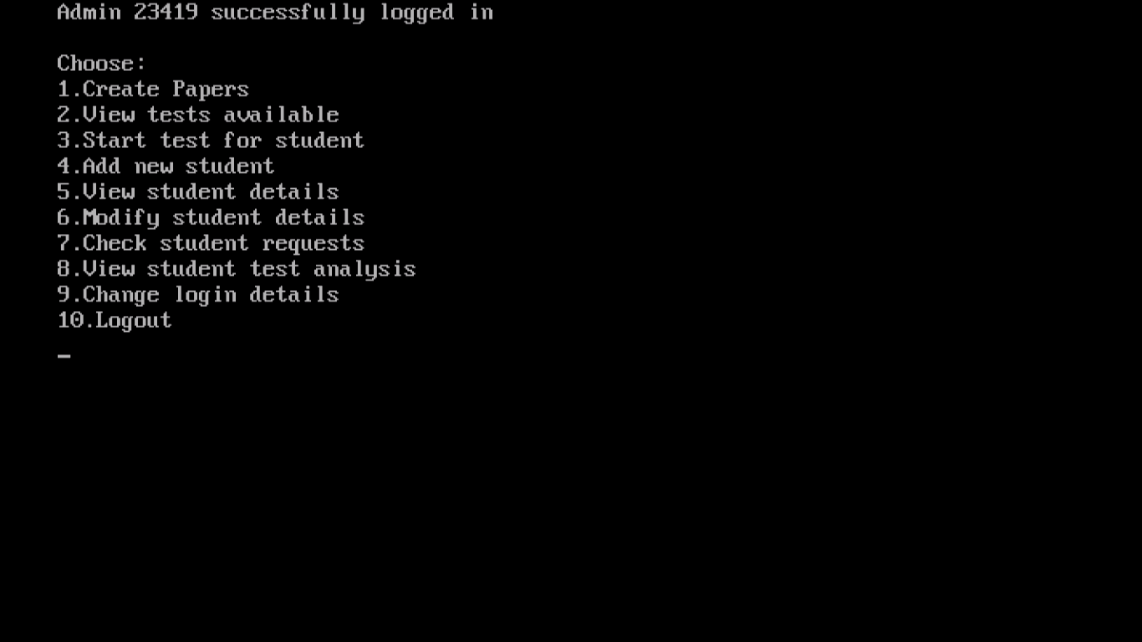

Admin - Creating new student

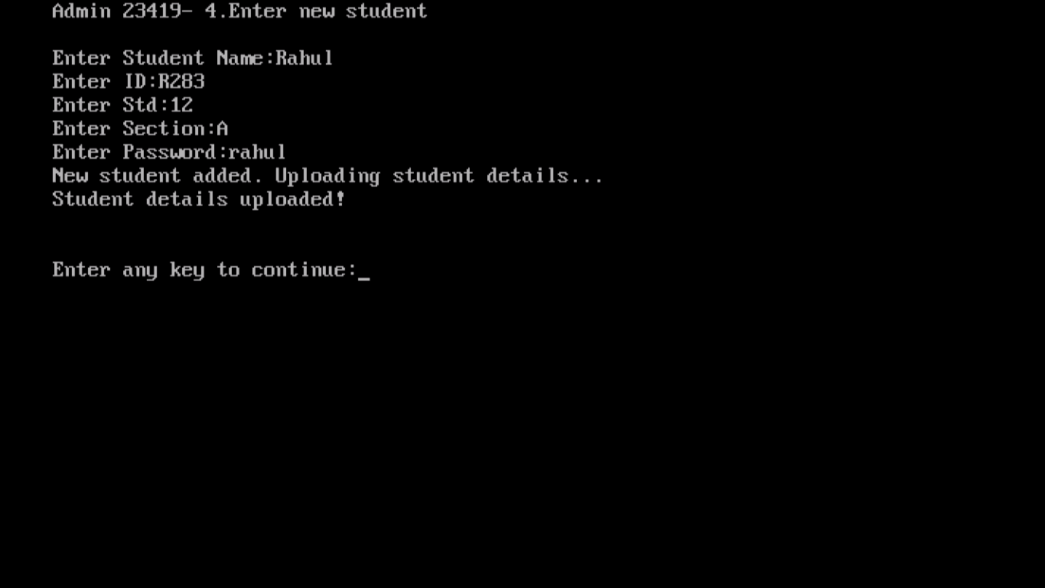

Admin – Creating new student

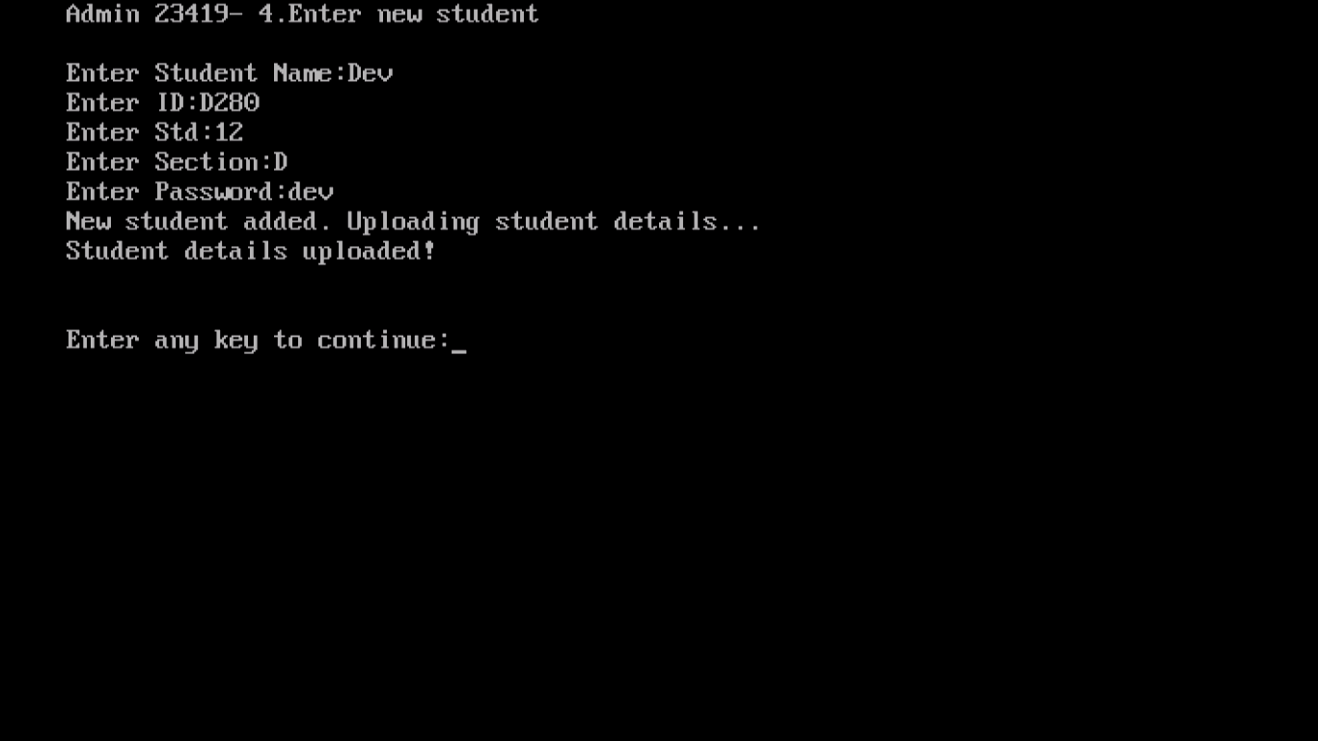

Admin – Viewing list of students

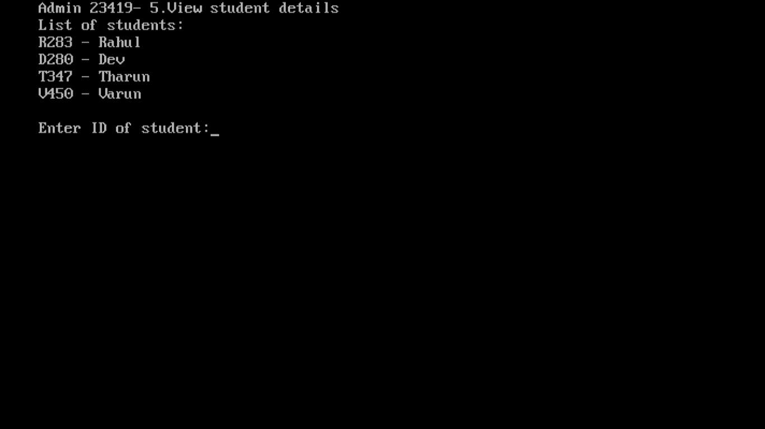

Admin – Viewing student details

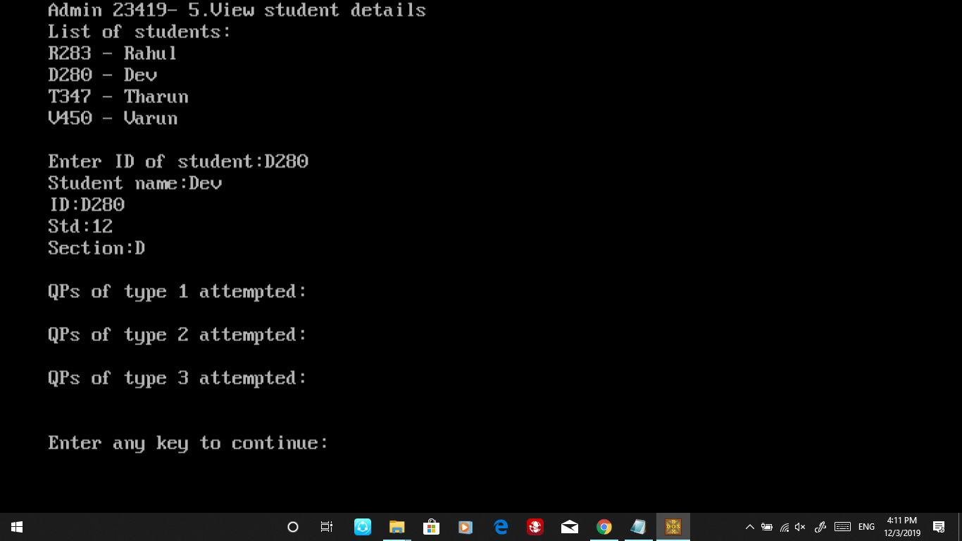

Admin – Editing student details

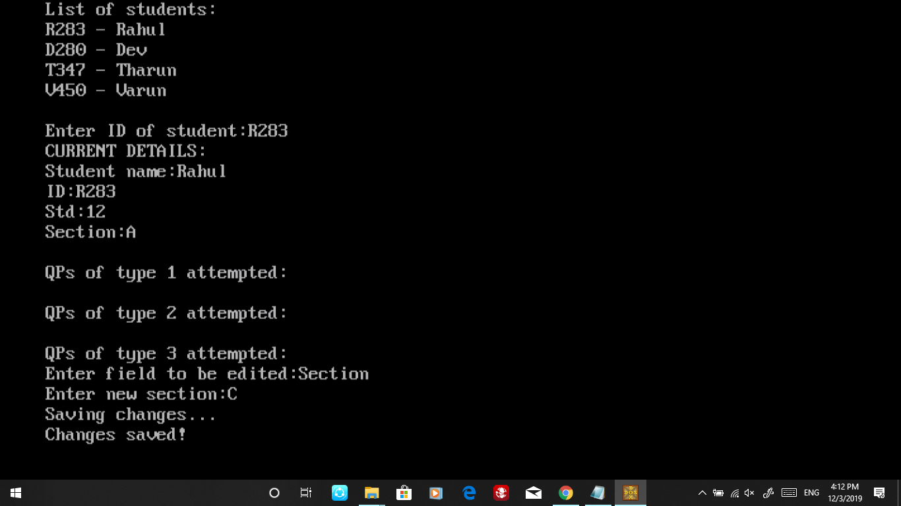

Student home screen, after logging in

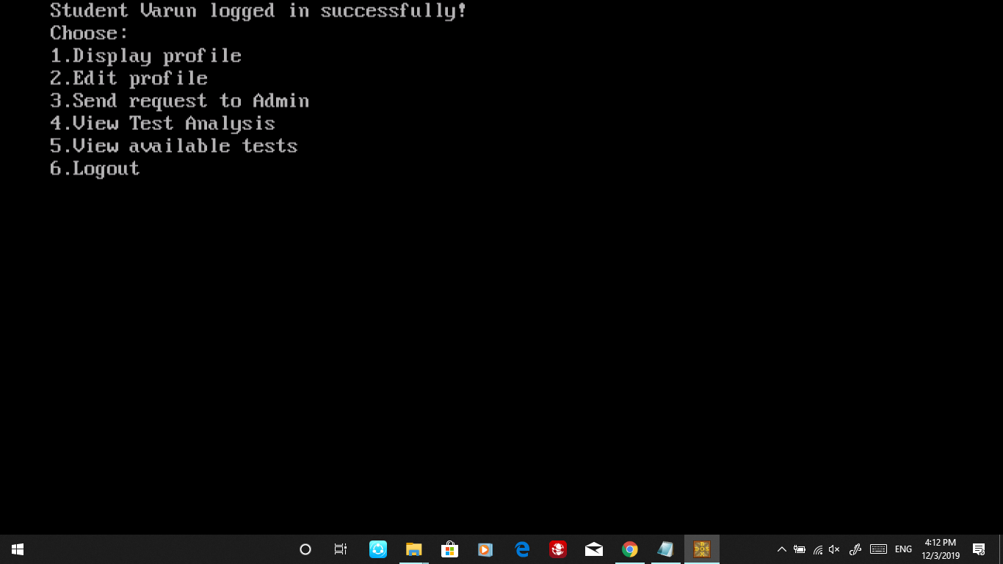

Student – Entering reuqest to Admin

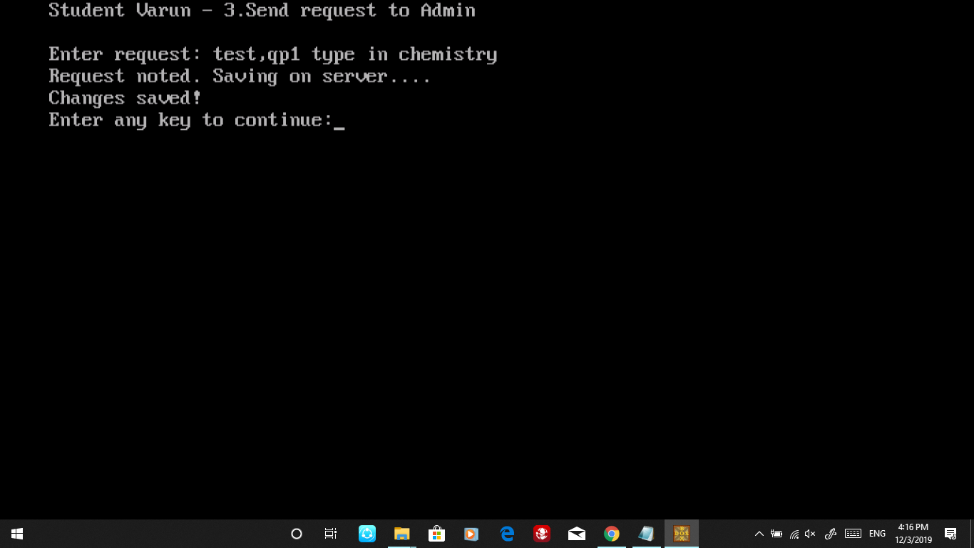

Student – Changing request to admin

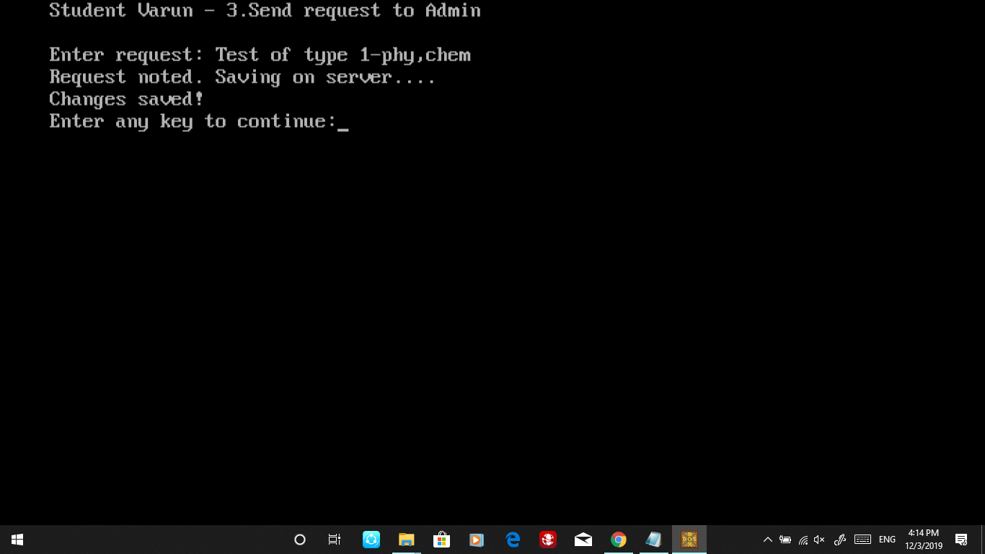

Admin – Viewing student details and requests

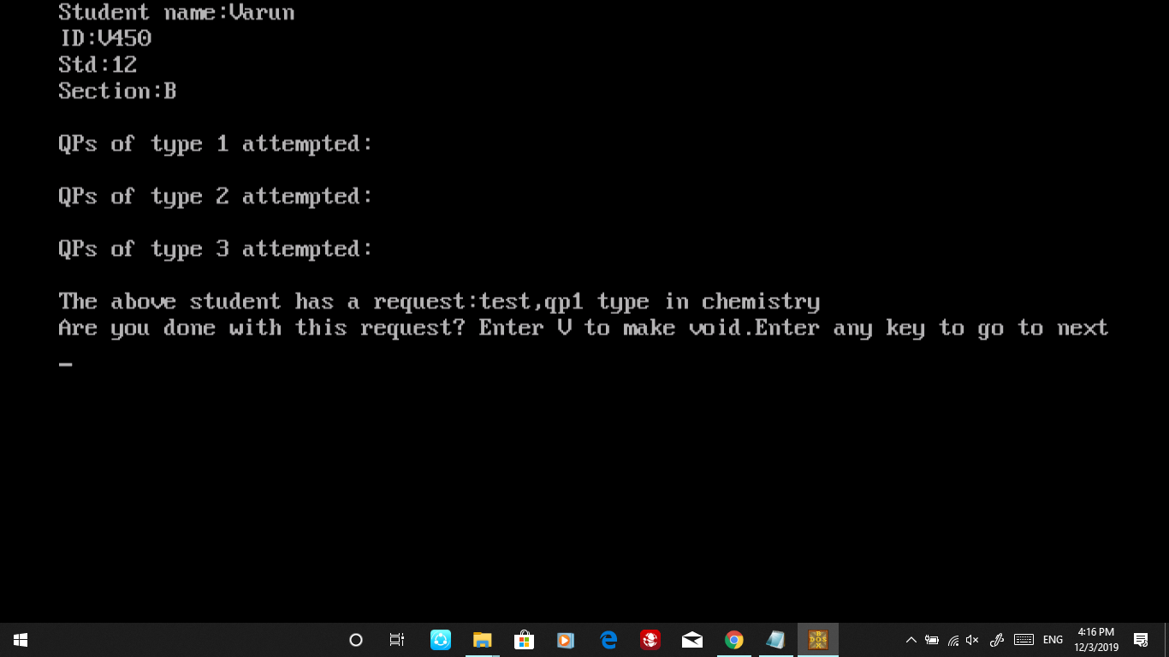

Admin – Creating Question paper of type 1

SCQ

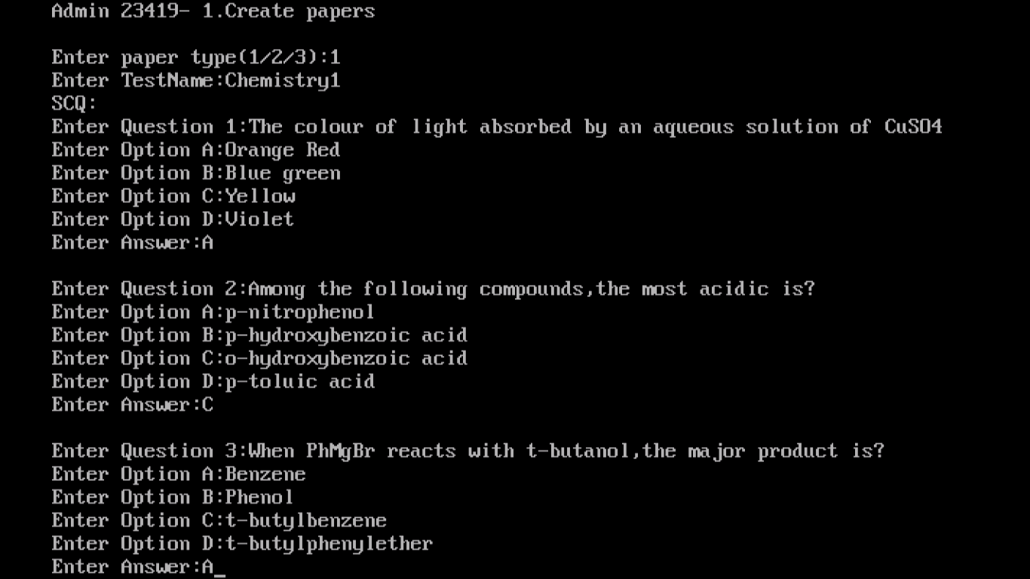

Numerical

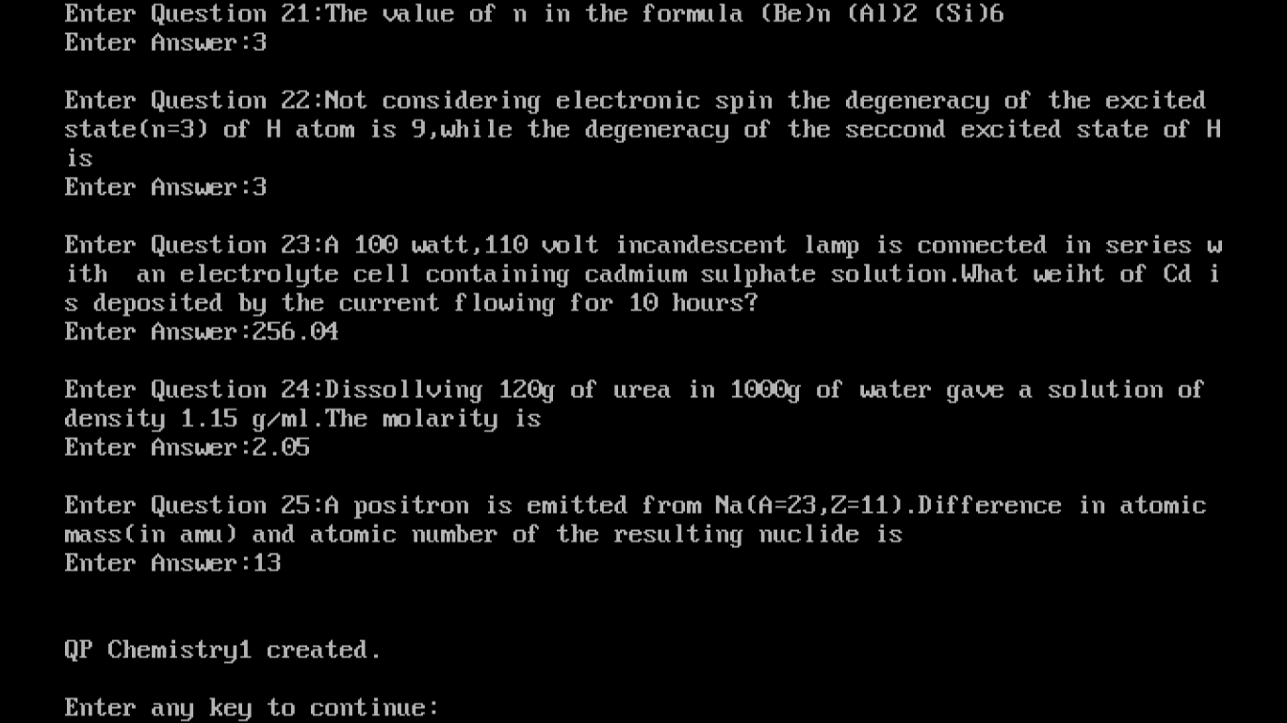

Admin – Starting Test Procedure (QP Type 1) for student

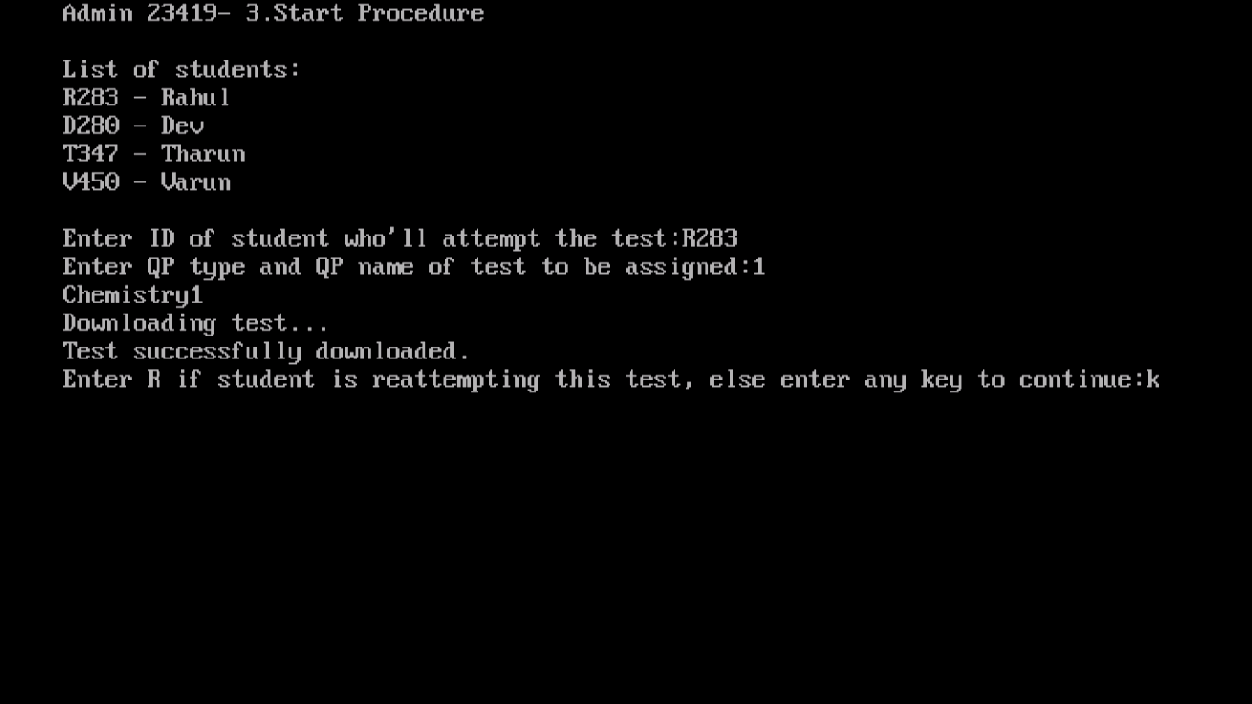

Student - Viewing Instructions for Test type 1

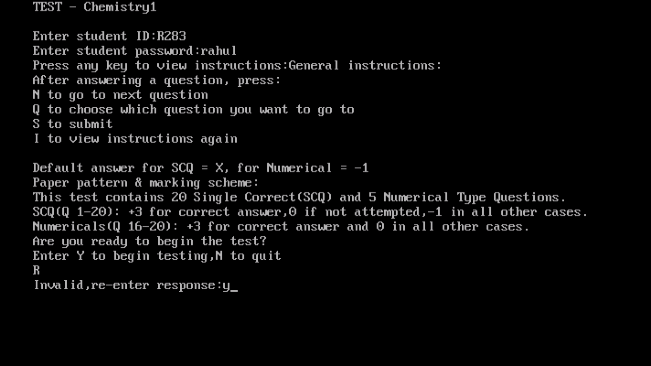

Student attempting Test Type 1

SCQ, Enters N to go to next question

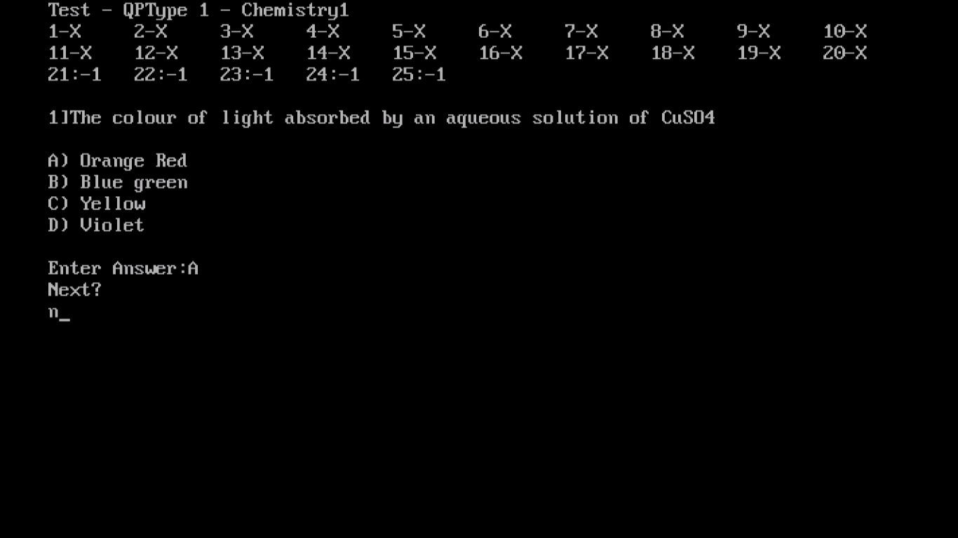

SCQ, Enters Q to go to question he wants to

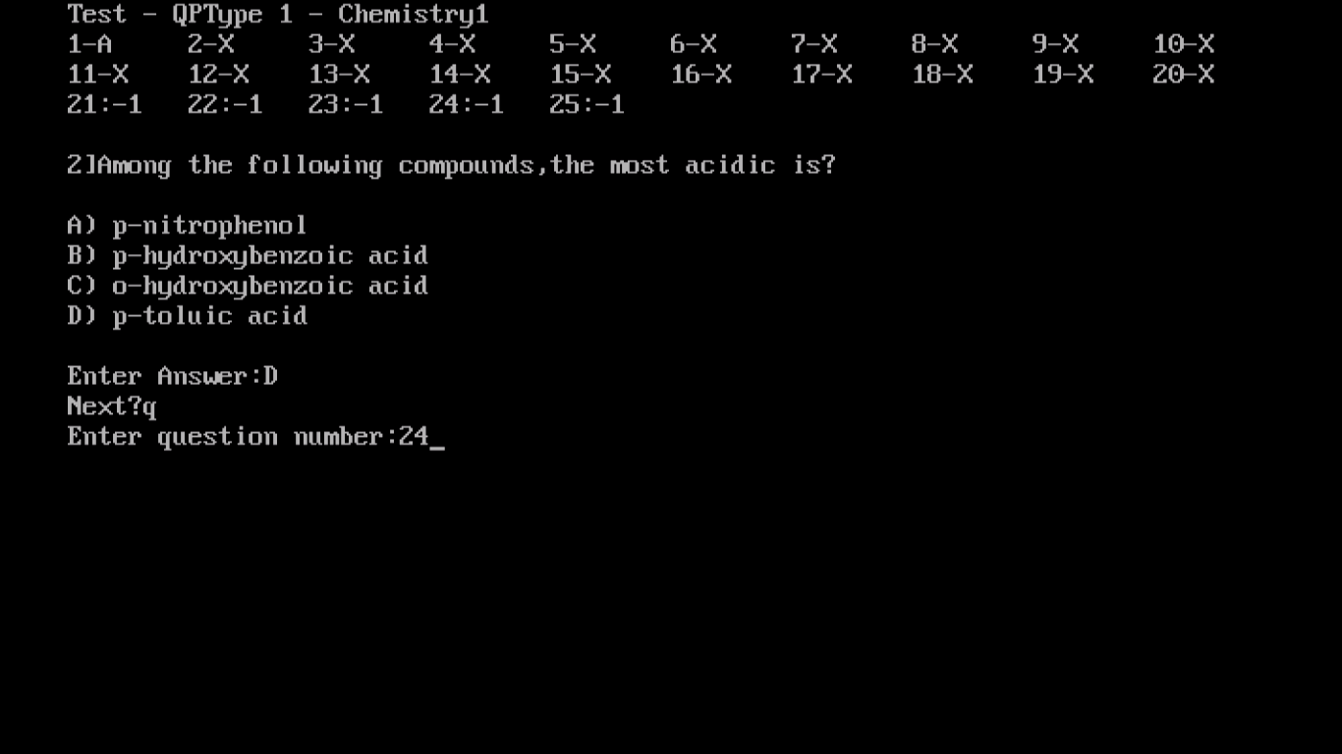

Student attempting Test Type 1

Numerical, Enters I to view instructions

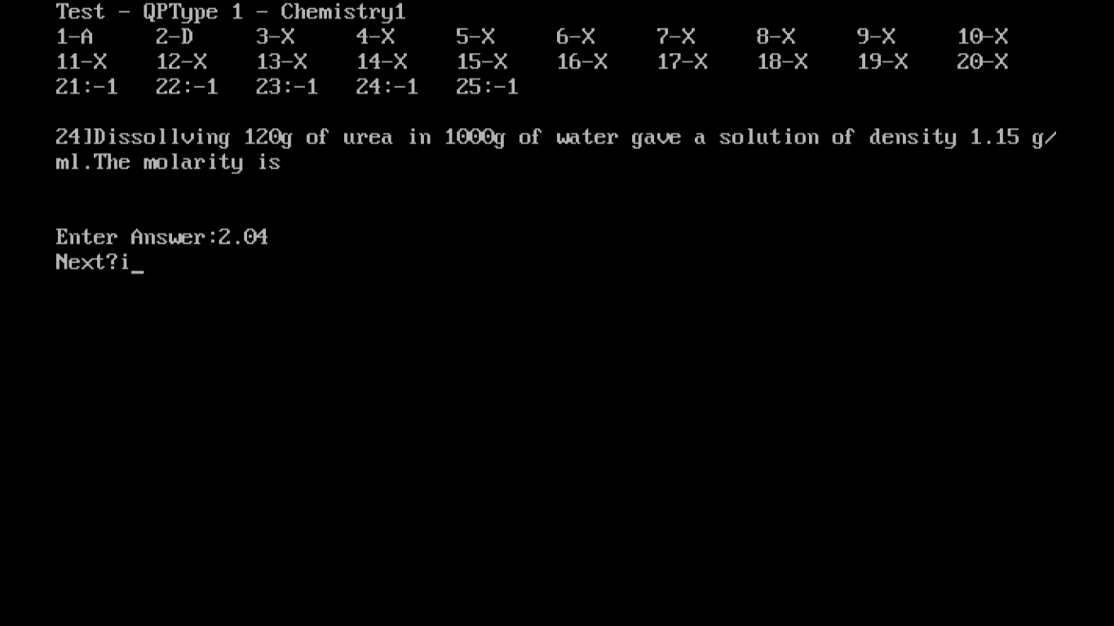

Viewing instructions during test

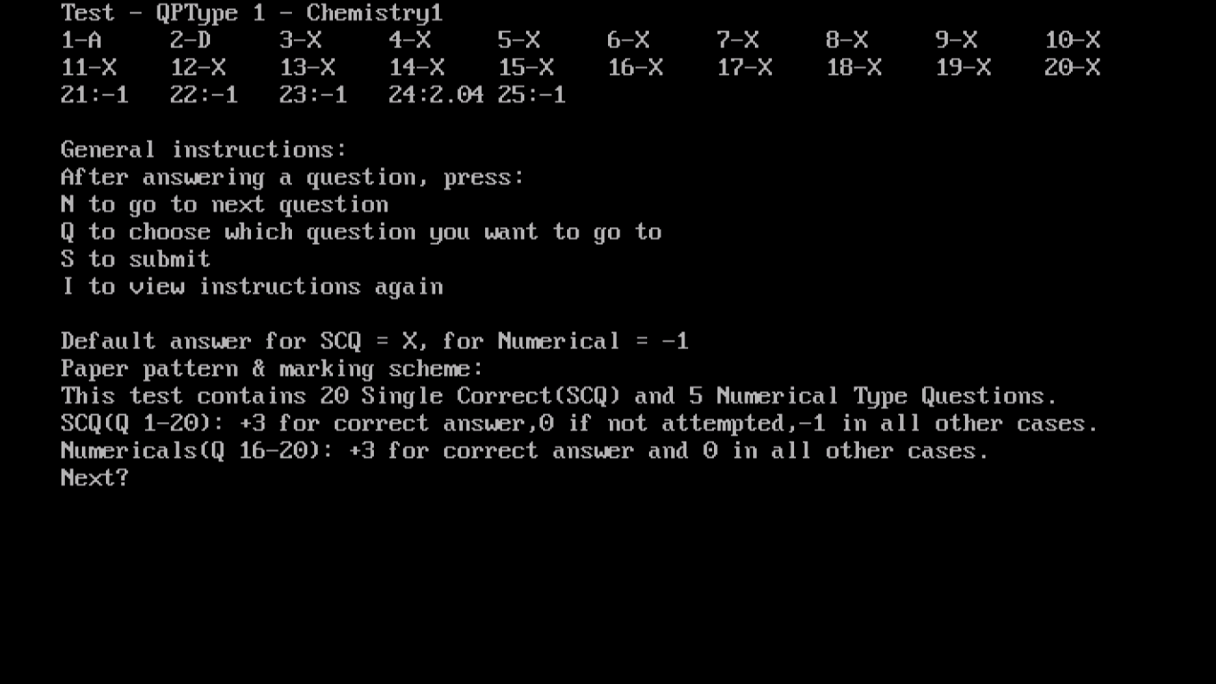

Student attempting Test Type 1

Enters S to submit

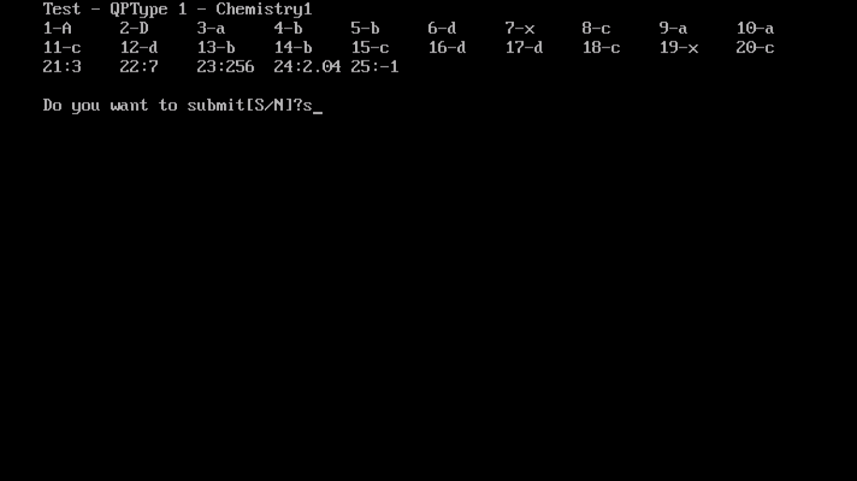

Views result after attempting Test

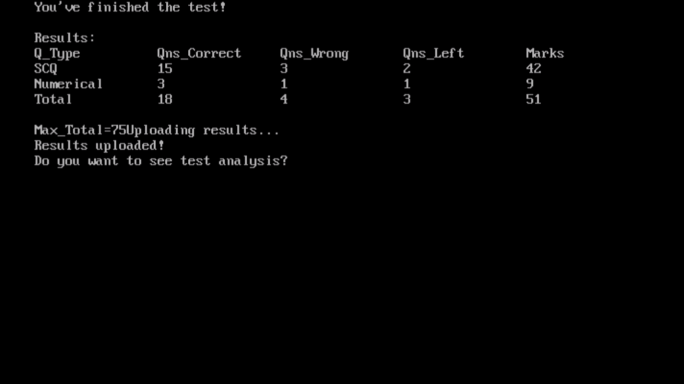

Test Analysis for TestType 1 – Test Report

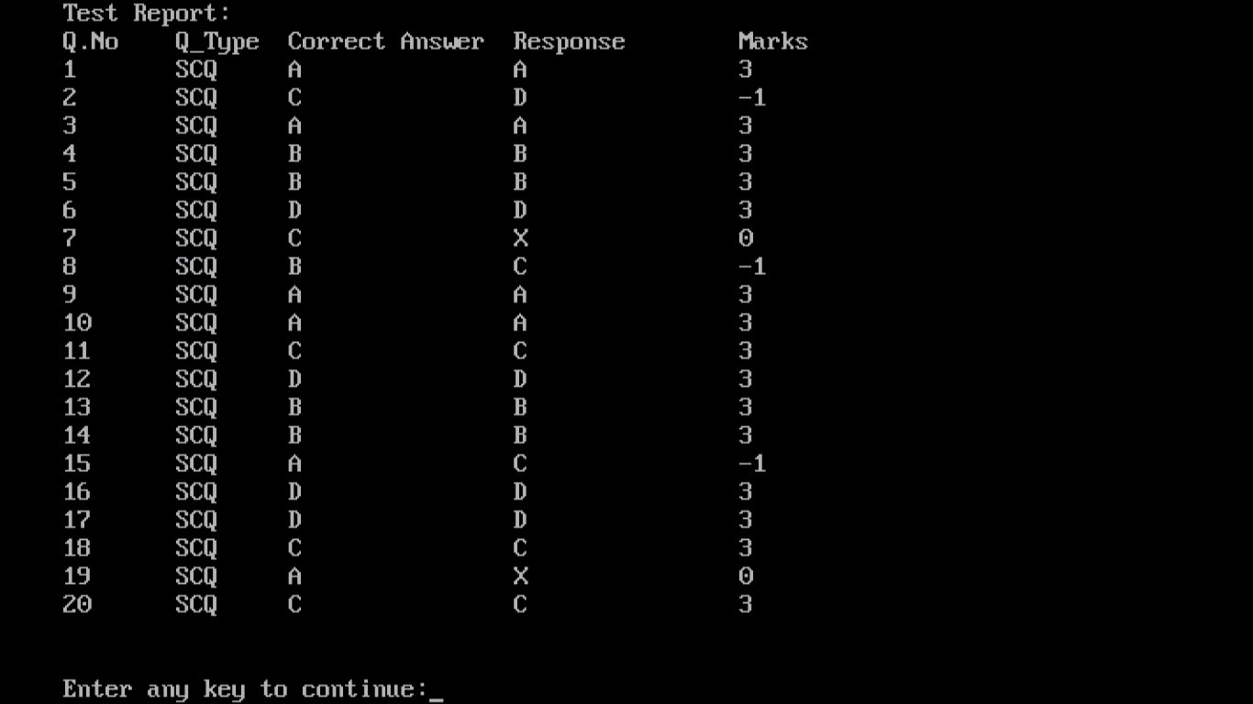

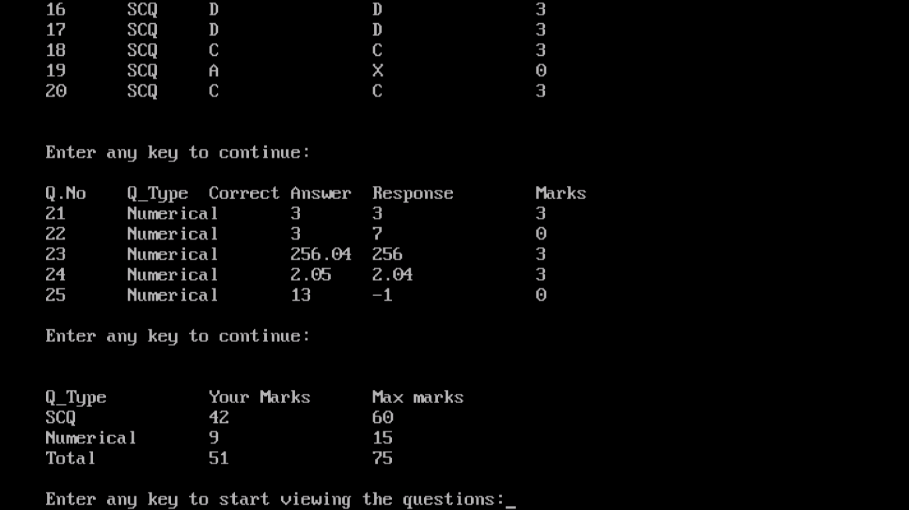

Test Analysis of TestType 1 – Viewing answers

SCQ

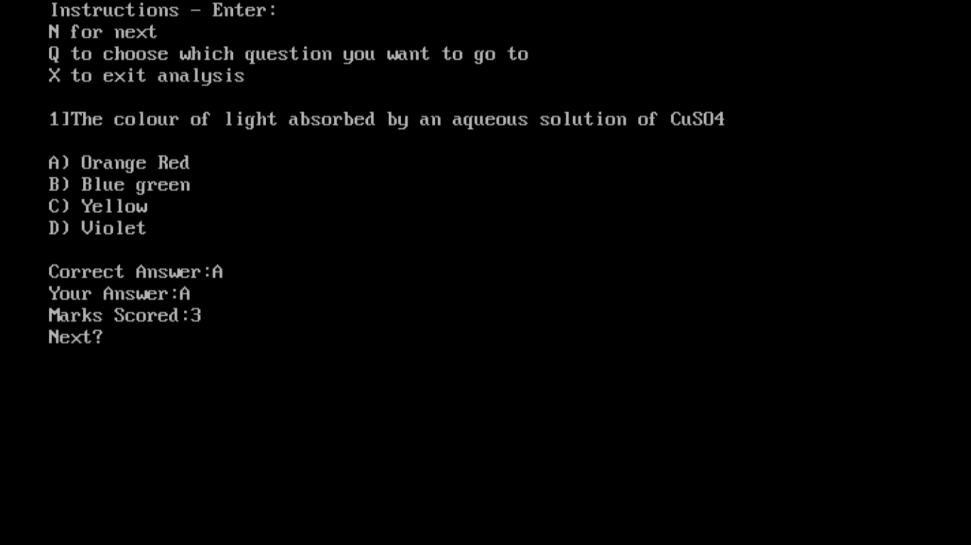

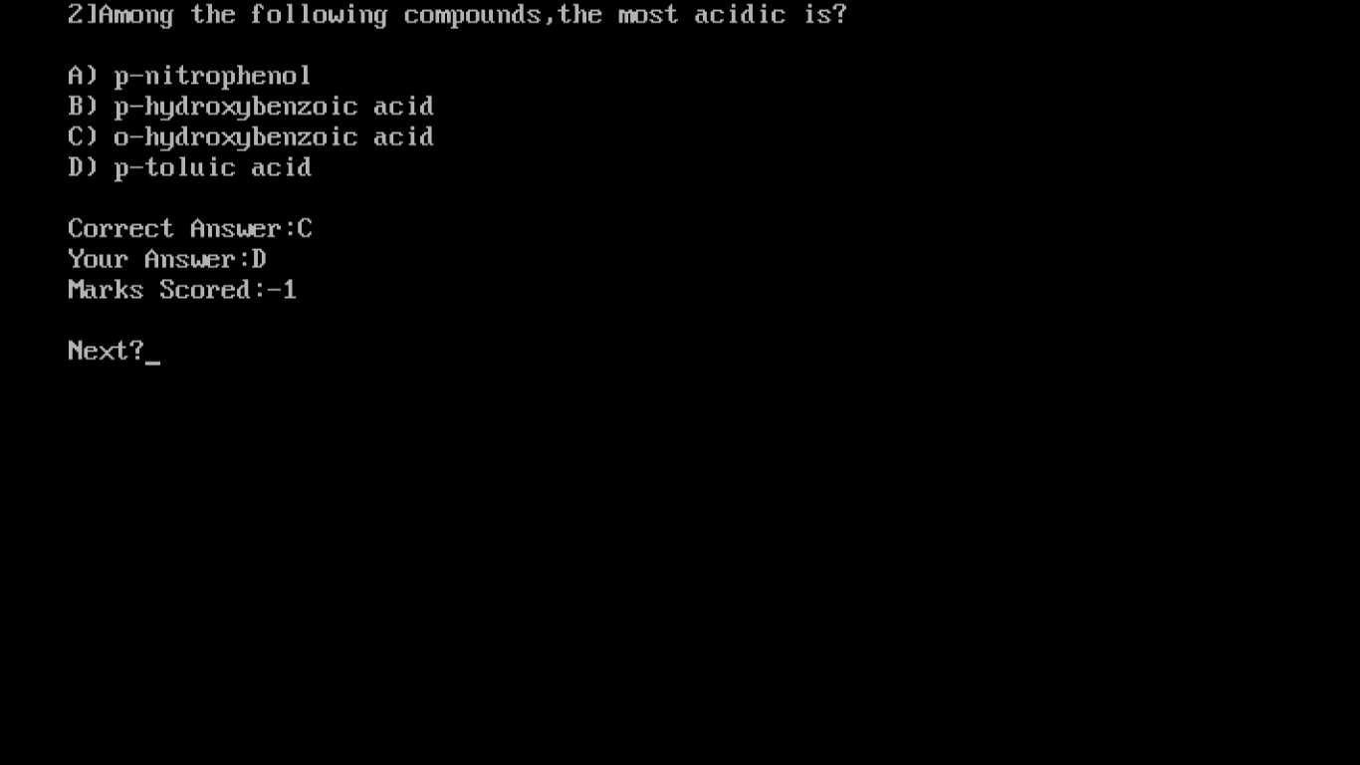

Test Analysis of TestType 1 – Viewing answers

Numerical

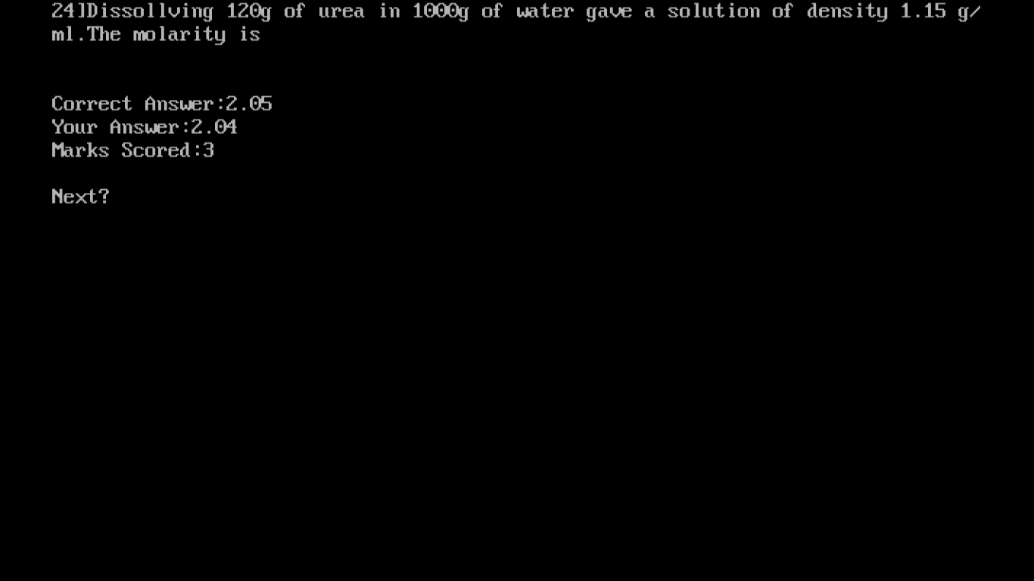

Admin – Creating MCQ Questions (QP Type 2)

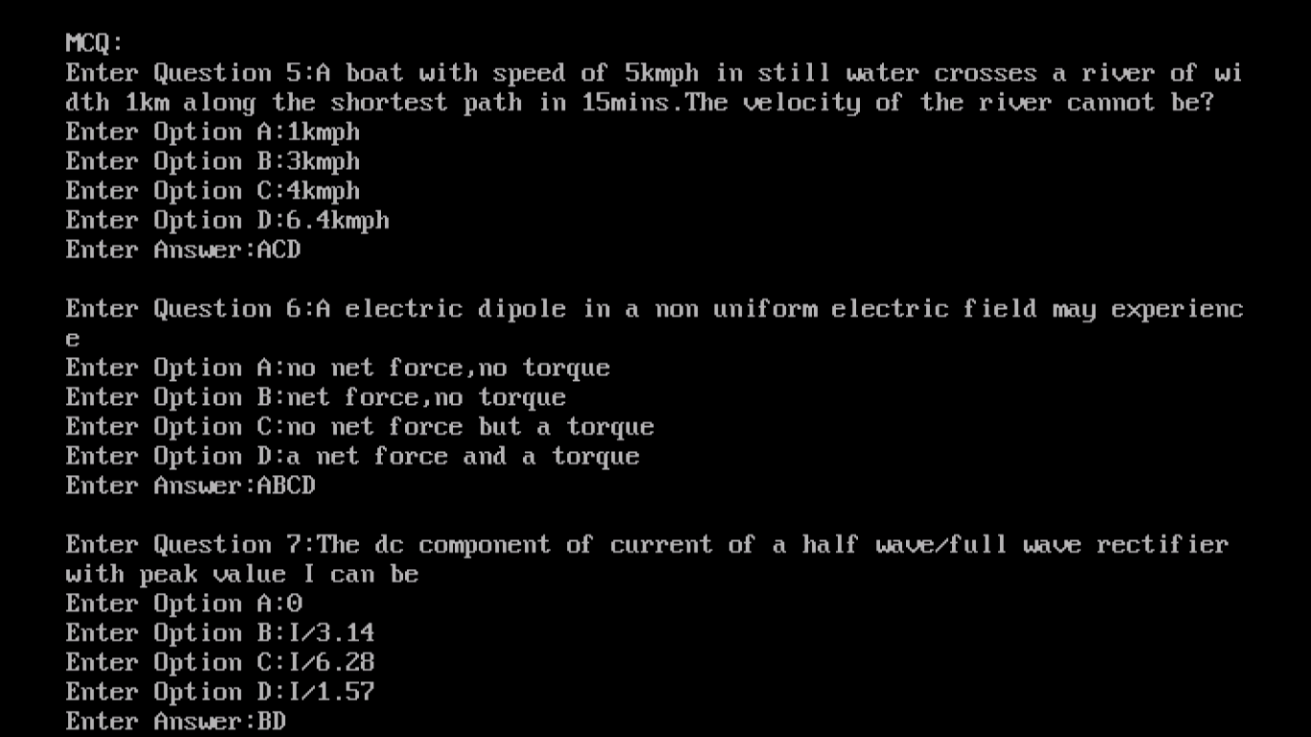

Admin – Starting Test of Type 2 for student

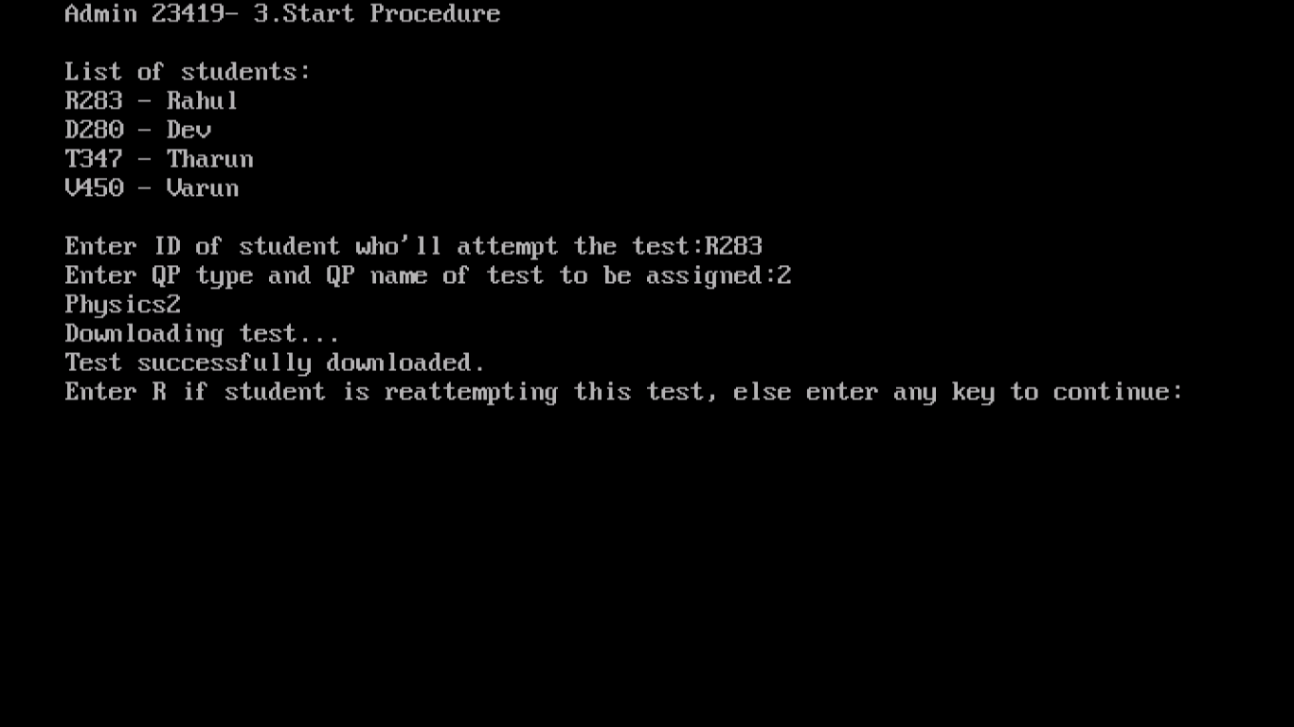

Student – Viewing Instructions for Test type 2 before starting test

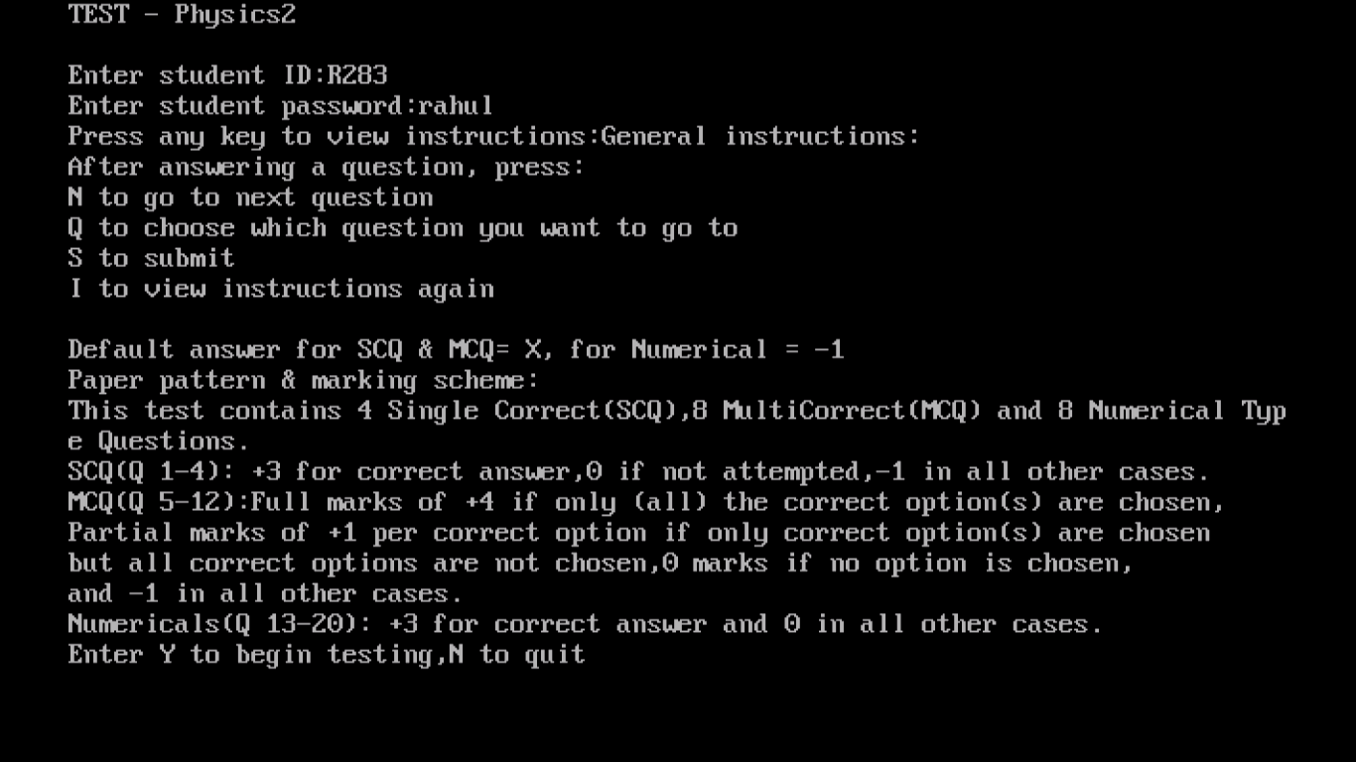

Student – attempting MCQ in Test of type 2

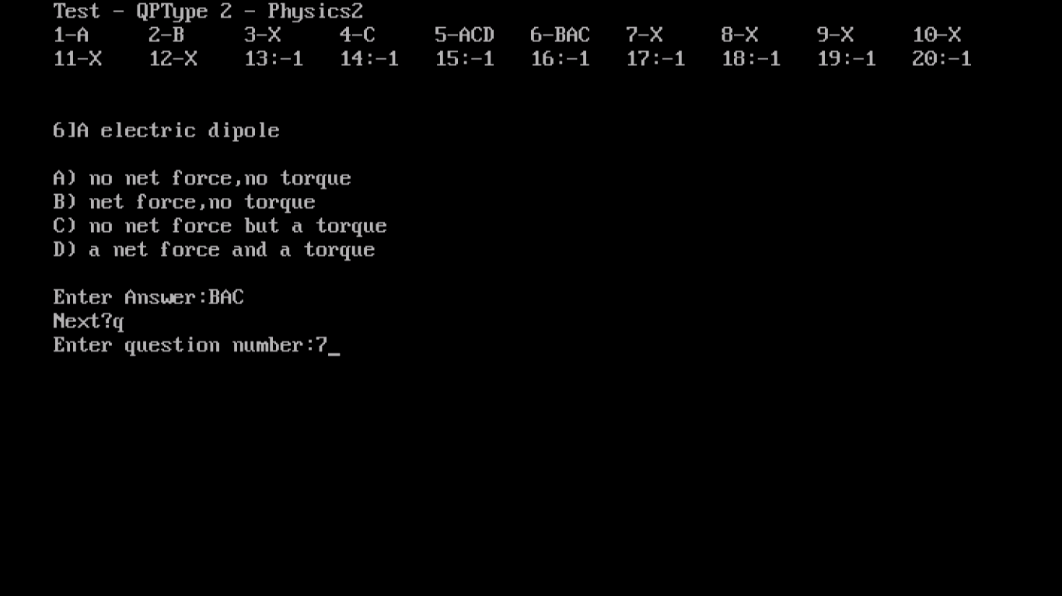

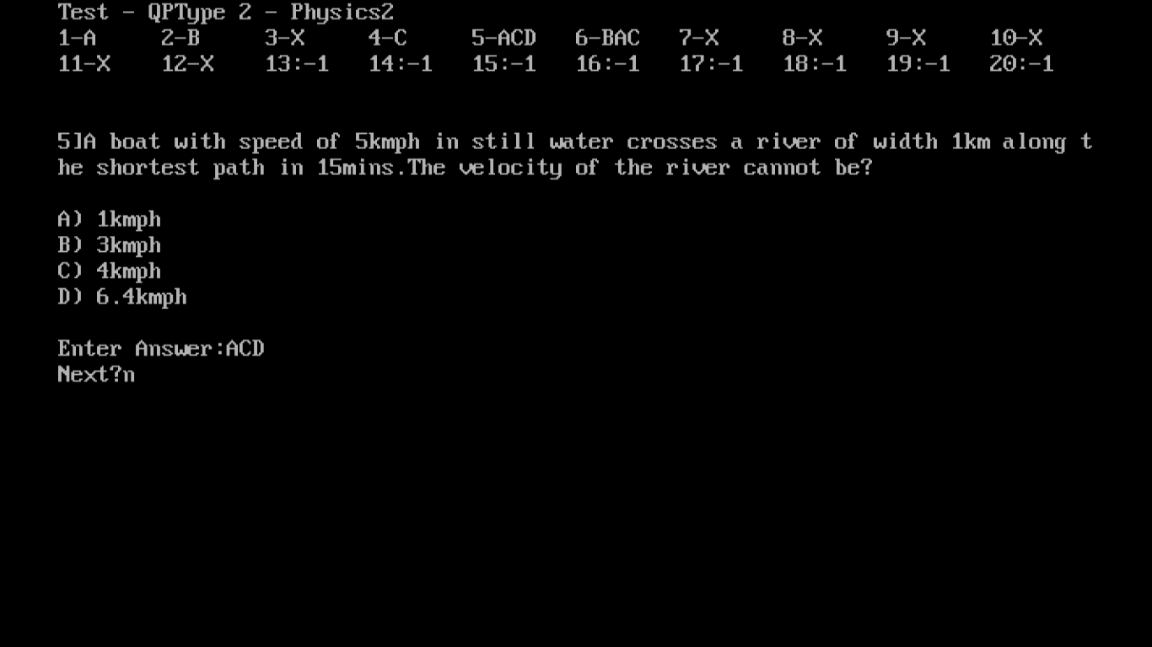

Student – Submitting Test of type 2

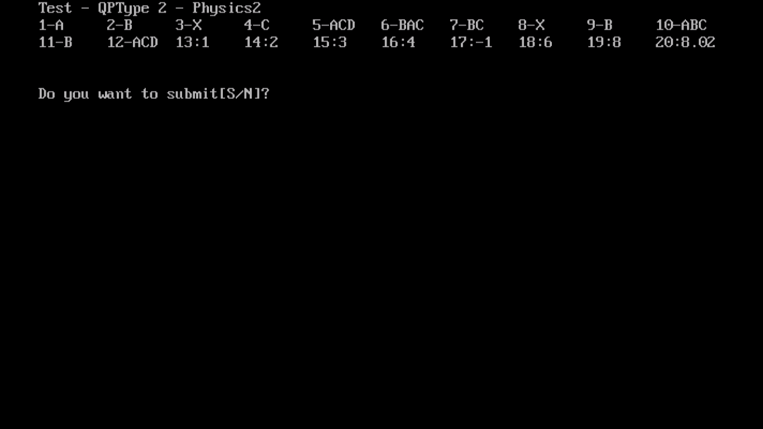

Student - Viewing Results of Test Type 2

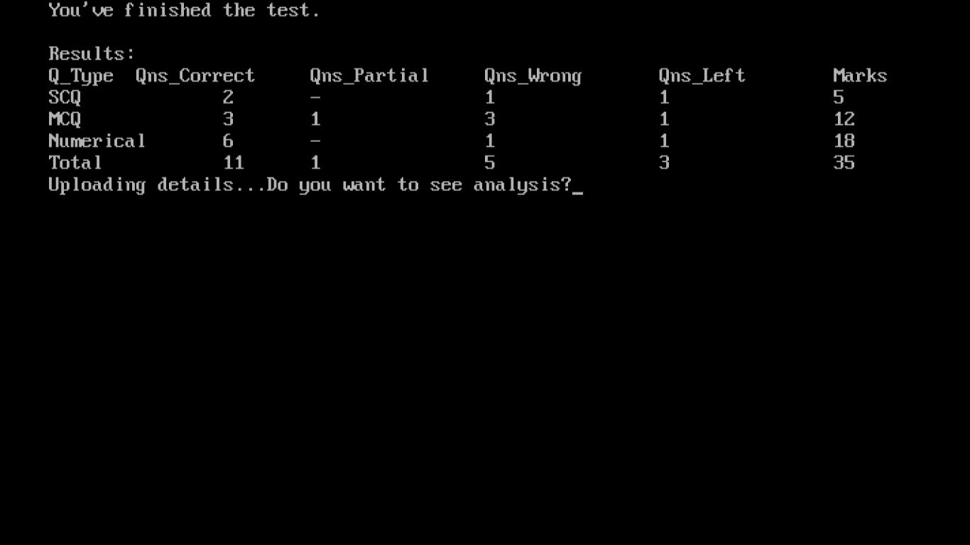

Test Analysis for TestType 2

Test Report

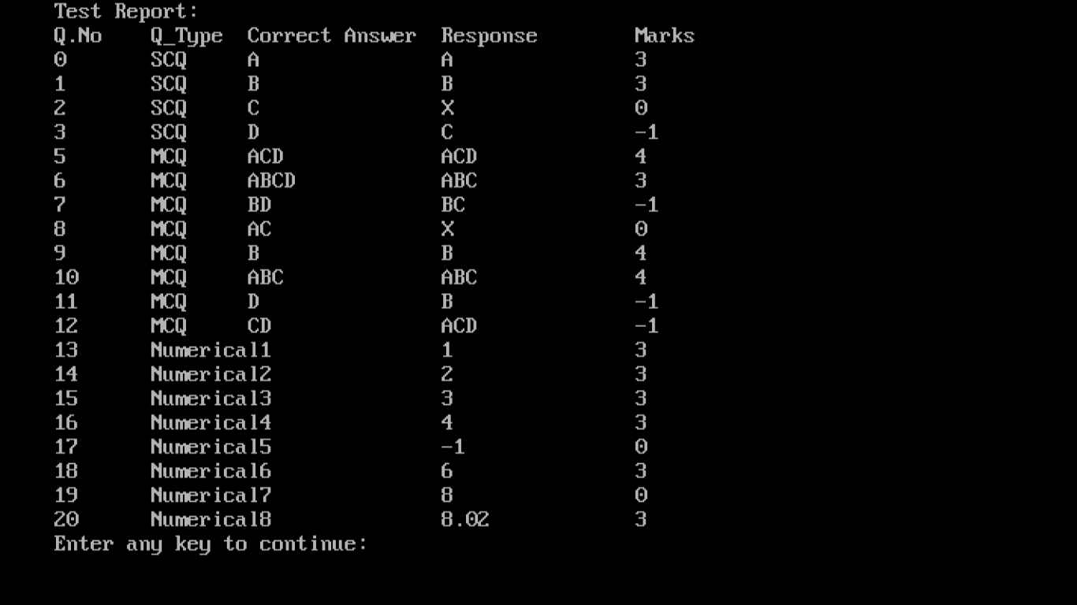

Viewing Questions in test analysis

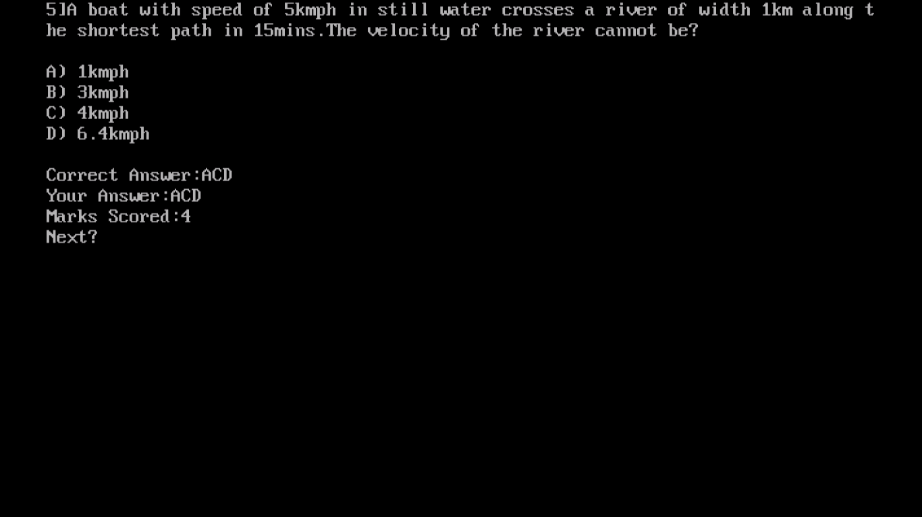

Test Analysis for TestType 2 – Test Report

Viewing Questions in test analysis

(Partial Marking implemented)

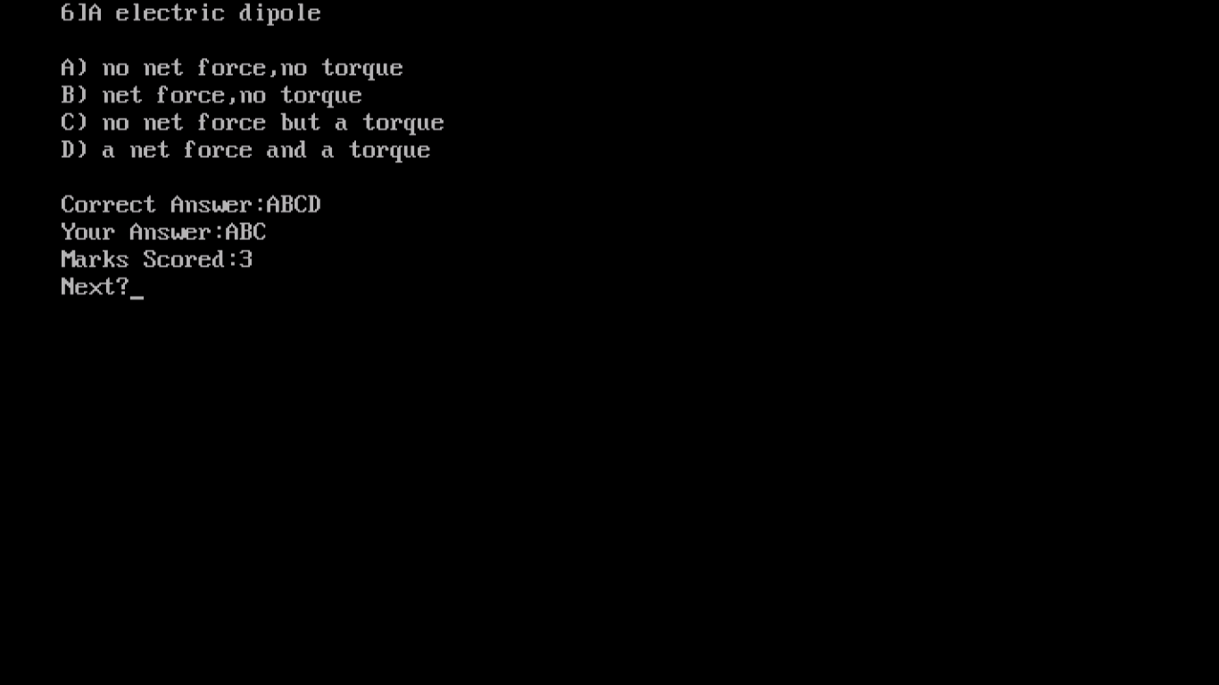

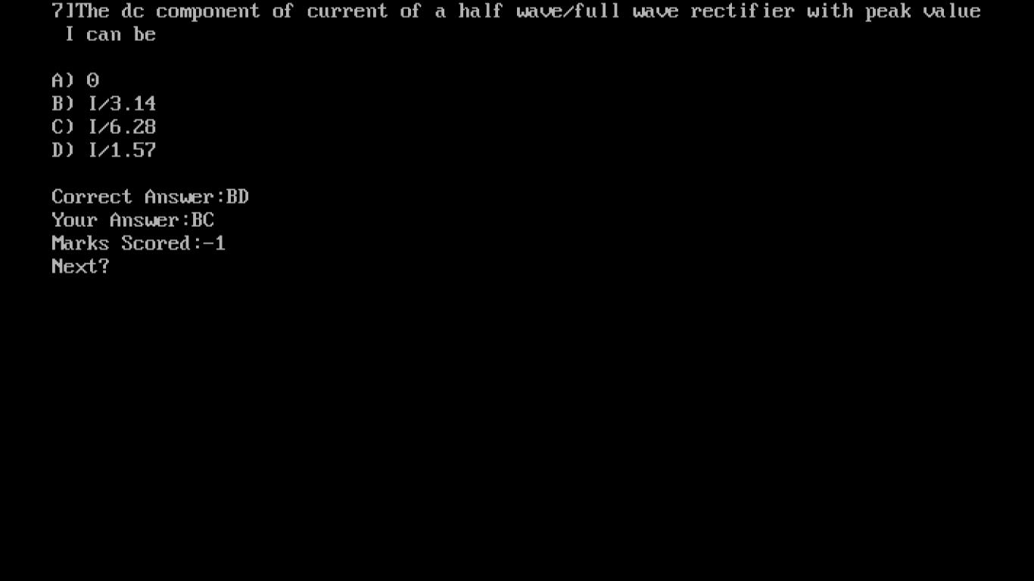

Admin – Creating a Matrix Match in paper of QP Type 3

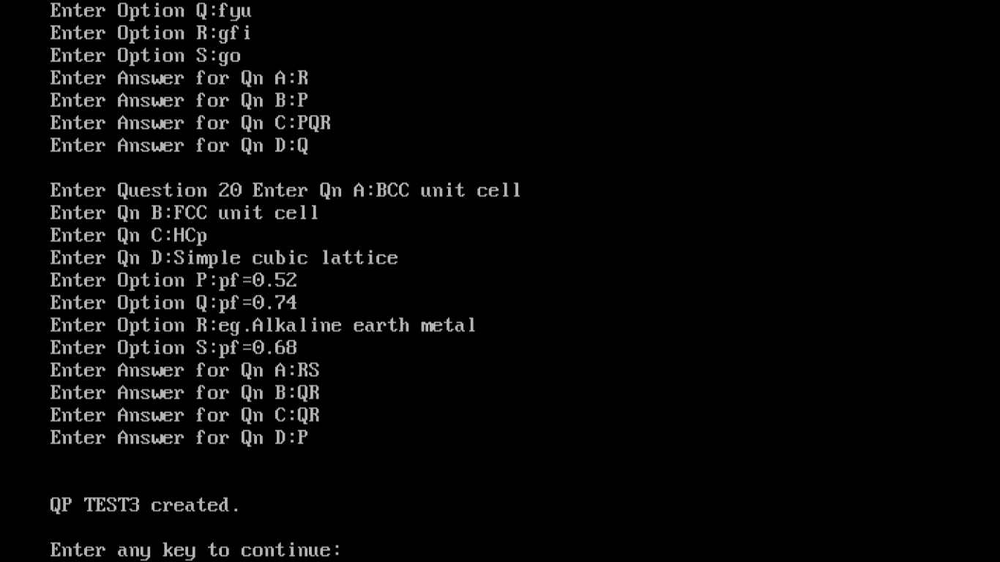

Admin – Starting Test of Type 3 for student

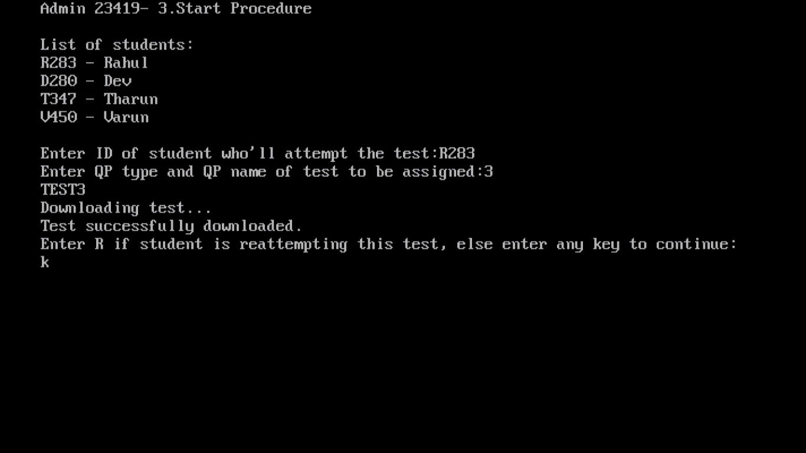

Student – Viewing Instructions for Test type 3 before starting test

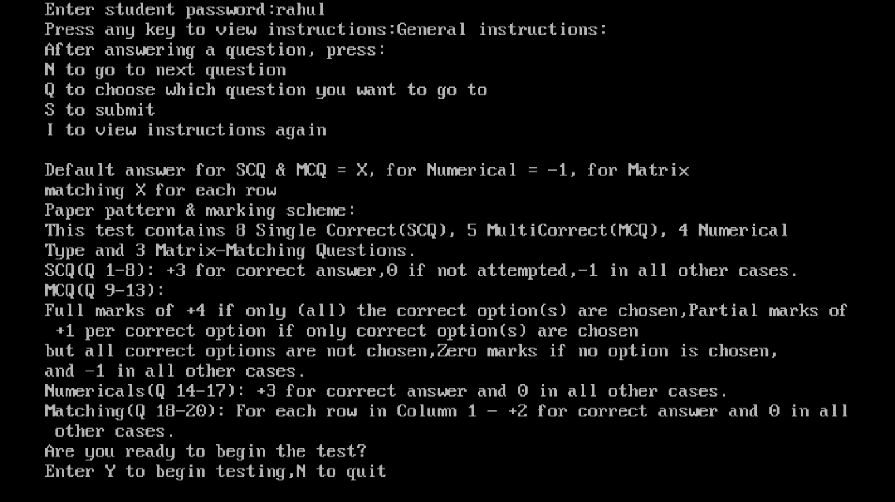

Student – Attempting a Matrix Match Question in Test of Type 3

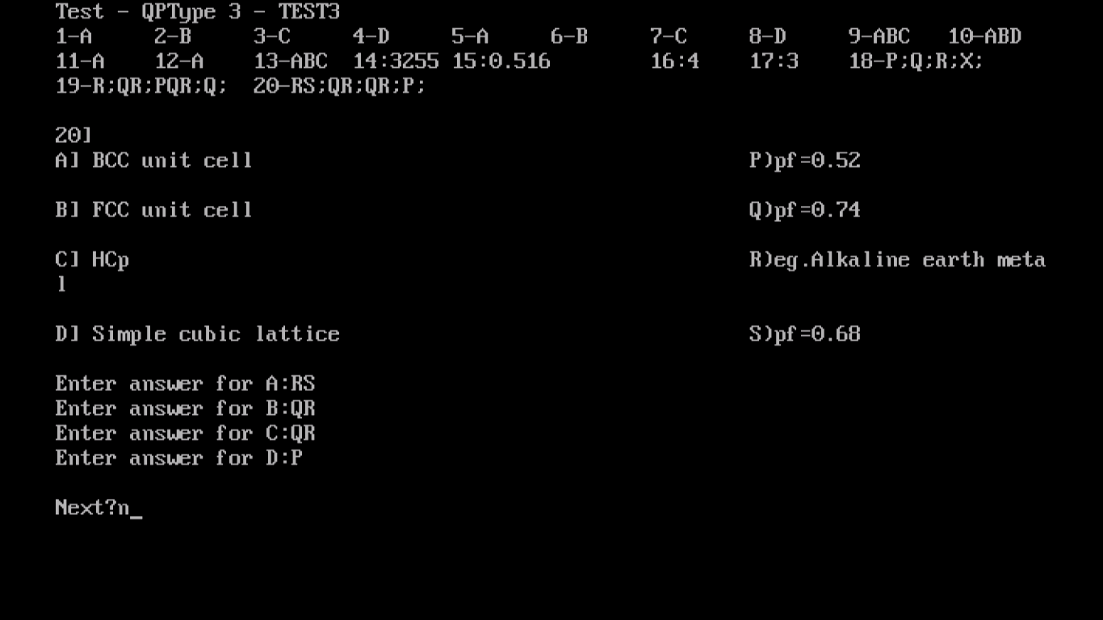

Test Analysis for TestType 3

Test Report

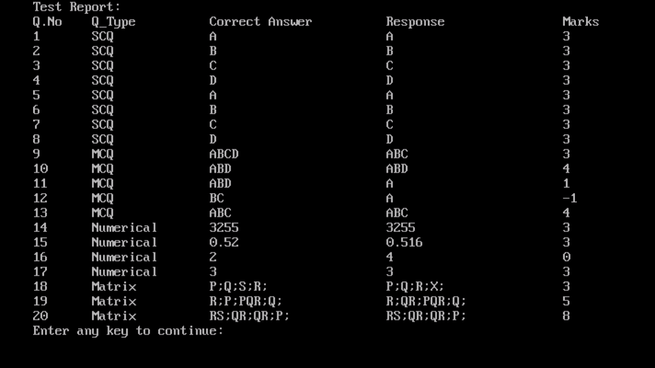

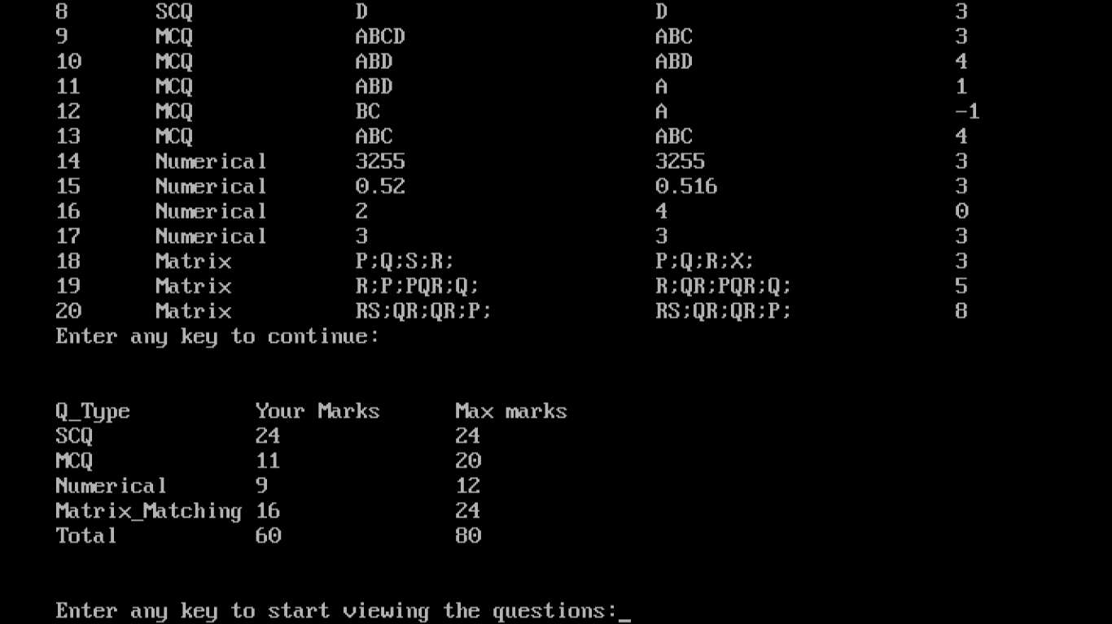

Test Analysis of TestType 3 – Viewing answers

Matrix-Matching

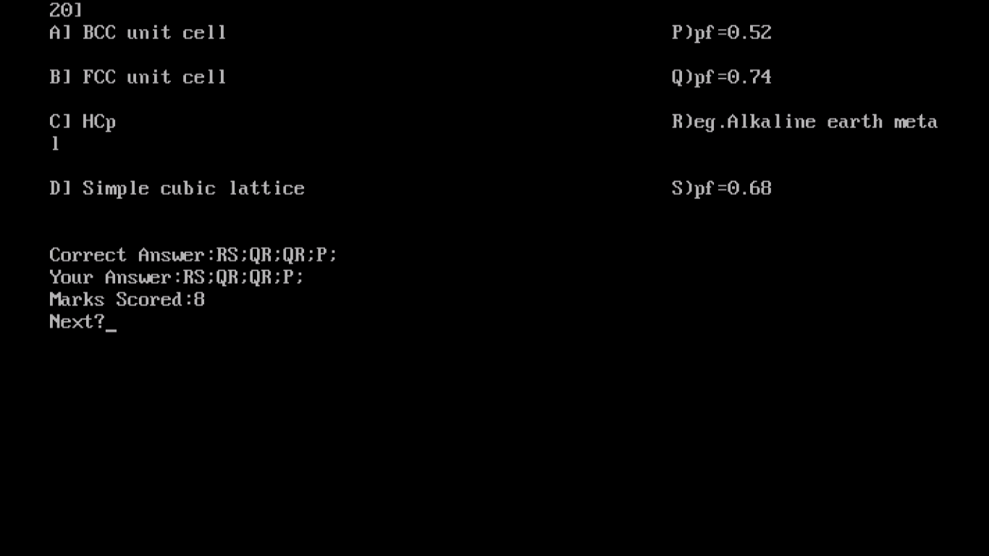

Admin – Viewing student details after student attempted tests

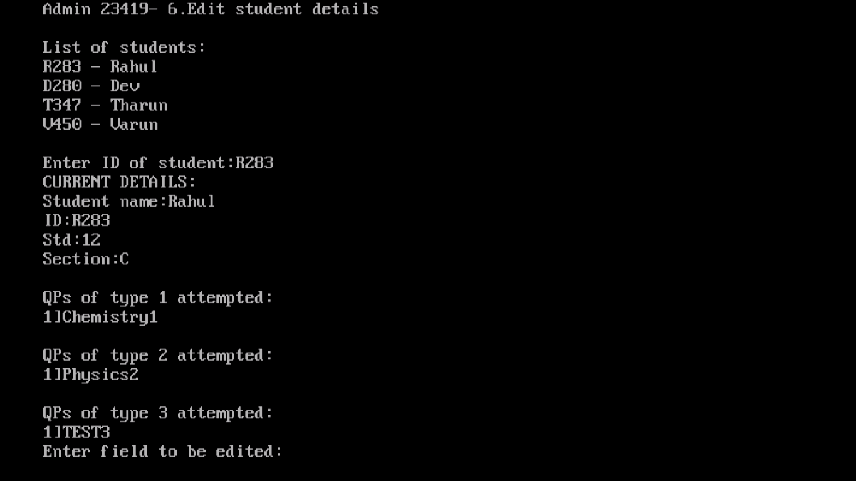

Admin – Viewing available tests

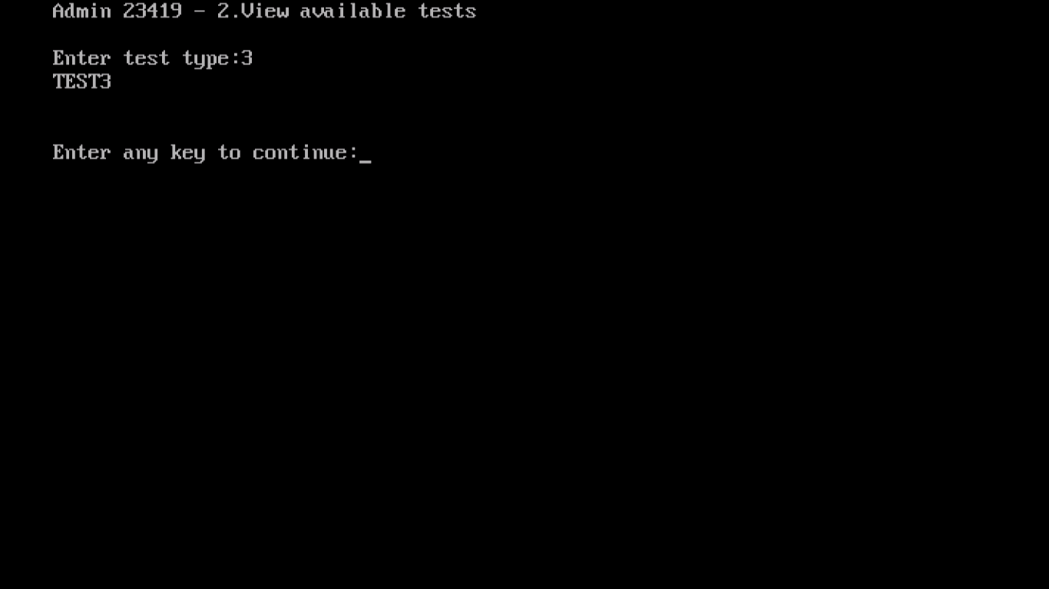

Admin functionality to view test analysis of student

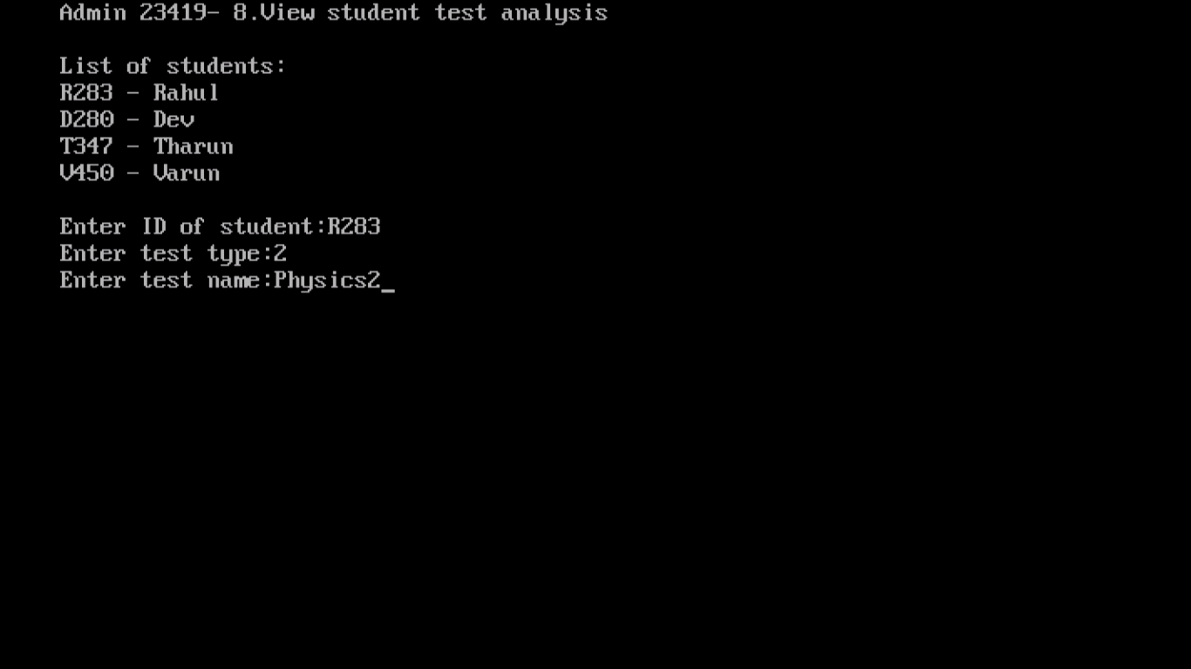

Admin – Changing Login details

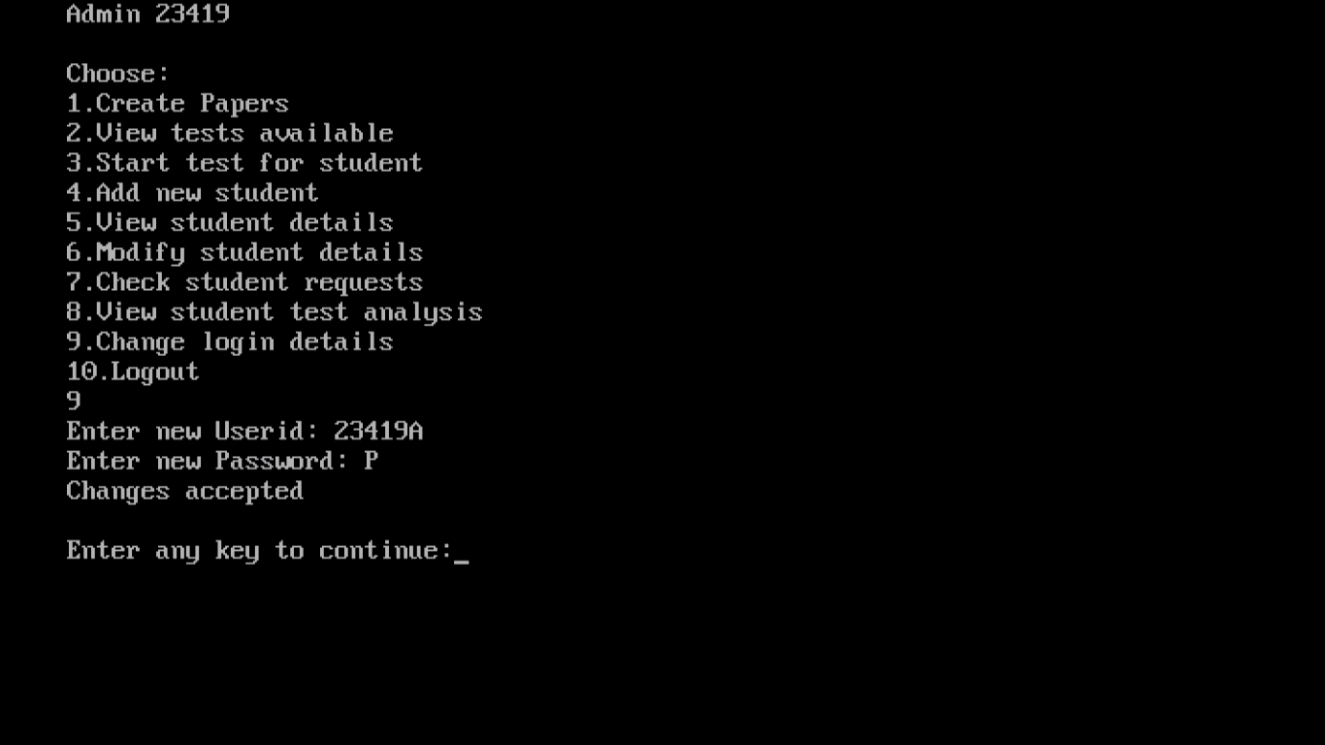

Admin – with changed login details

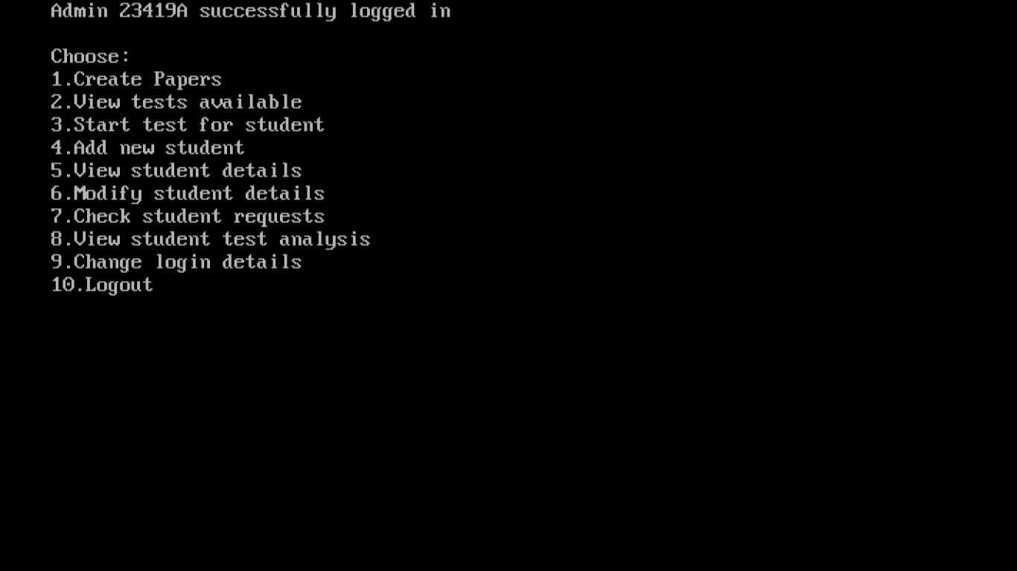

Student – Viewing his/her details

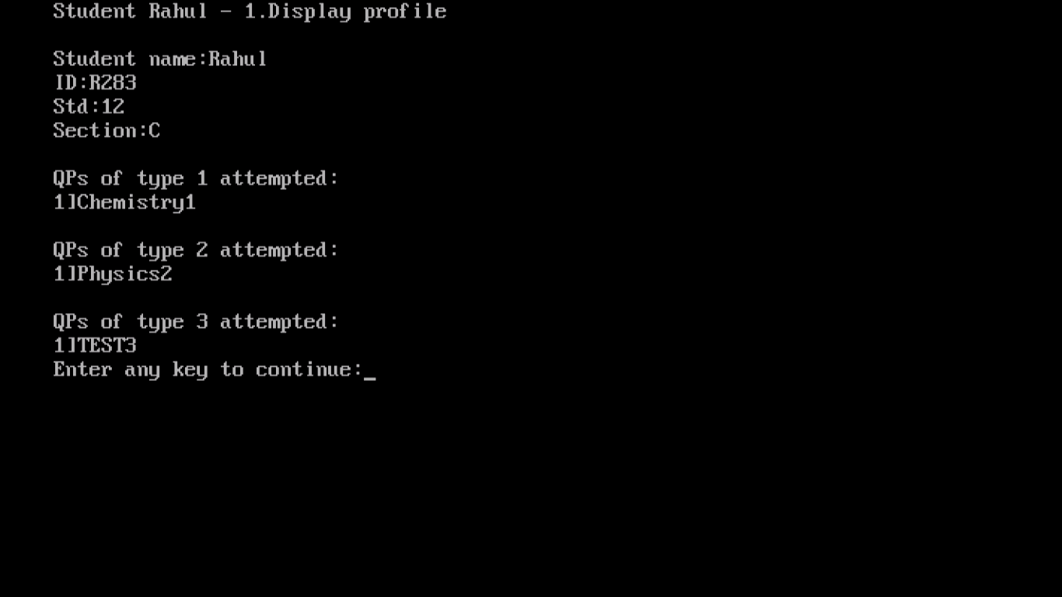

Student – Viewing available tests

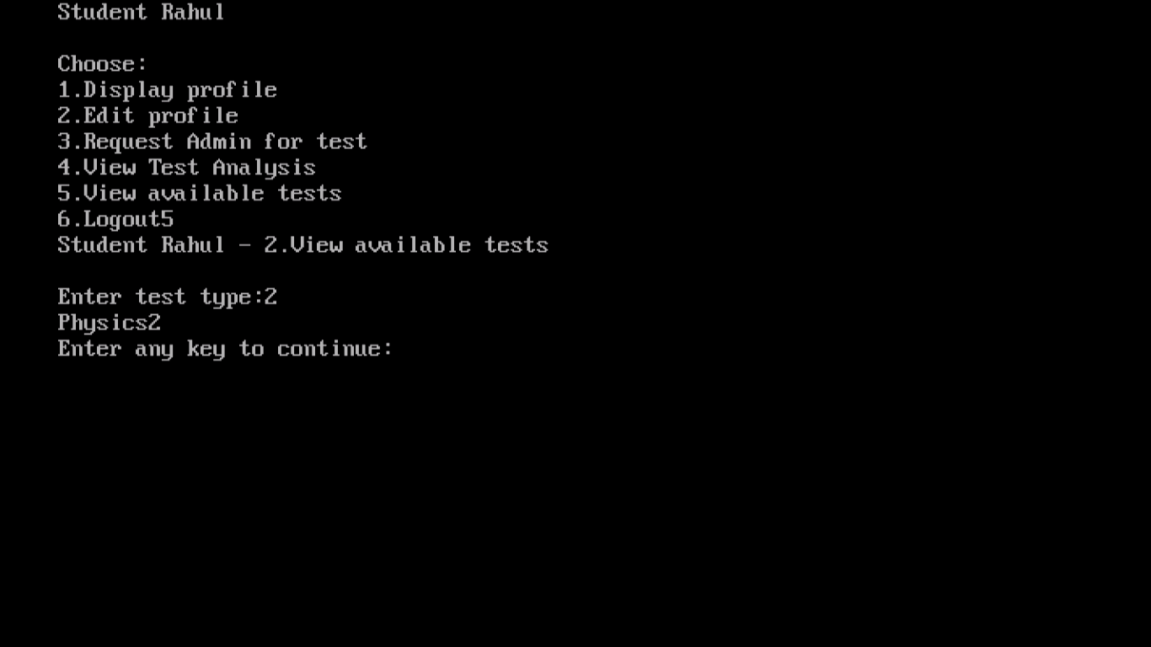

Login screen of program

